1. **Probability Addition Theorem**

The addition theorem is used to calculate the probability of the occurrence of at least one of two events. It depends on whether the events are **mutually exclusive** (cannot occur together) or not mutually exclusive (can occur together).

* **Mutually Exclusive**: Events that cannot happen at the same time. E.g., getting a 2 and a 5 in one single die roll.
* **Not Mutually Exclusive**: Events that can happen together. E.g., drawing a red card and a king (since some red cards are kings too).

**Formula:**

* **Mutually exclusive**:

P(A∪B)=P(A)+P(B)

* **Not mutually exclusive**:

P(A∪B)=P(A)+P(B)−P(A∩B)

**Program:-**

def addition_theorem(P_A, P_B, P_A_and_B=None):

if P_A_and_B is None:

return P_A + P_B

else:

return P_A + P_B - P_A_and_B

P_A = float(input("Enter P(A): "))

P_B = float(input("Enter P(B): "))

choice = input("Are the events mutually exclusive? (yes/no): ")

if choice.lower() == "yes":

result = addition_theorem(P_A, P_B)

else:

P_A_and_B = float(input("Enter P(A ∩ B): "))

result = addition_theorem(P_A, P_B, P_A_and_B)

print(f"P(A ∪ B) = {result}")

**Output:**

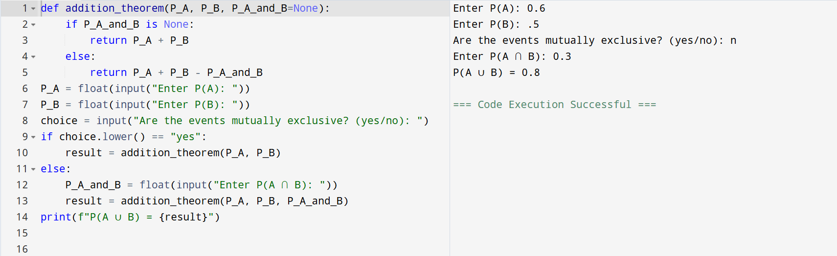

**Q)** In a class:

* 40% of students like Math → P(A)=0.6
* 50% like Science → P(B)=0.5
* 20% like both Math and Science → P(A∩B)=0.3

What is the probability that a student likes Math or Science?

Solution:

P(A∪B)=P(A)+P(B)−P(A∩B)

P(A∪B)=0.6+0.5−0.3=0.8

So, the probability that a student likes either Math or Science is **0.8**.

**2. Probability Multiplication Theorem**

**Explanation:**

The multiplication theorem helps us find the probability of both events A and B occurring. This depends on whether events are independent or dependent.

* **Independent**: One event doesn't affect the other (e.g., flipping a coin and rolling a die).
* **Dependent**: One event affects the outcome of the other (e.g., drawing cards without replacement).

**Formula:**

* **Independent Events**:

P(A∩B)=P(A)⋅P(B)

* **Dependent Events**:

P(A∩B)=P(A)⋅P(B∣A)

**Program:-**

def multiplication_theorem(P_A, P_B_or_P_B_given_A):

return P_A * P_B_or_P_B_given_A

P_A = float(input("Enter P(A): "))

independent = input("Are the events independent? (yes/no): ")

if independent.lower() == "yes":

P_B = float(input("Enter P(B): "))

result = multiplication_theorem(P_A, P_B)

else:

P_B_given_A = float(input("Enter P(B|A): "))

result = multiplication_theorem(P_A, P_B_given_A)

print(f"P(A ∩ B) = {result}")

**Output:-**

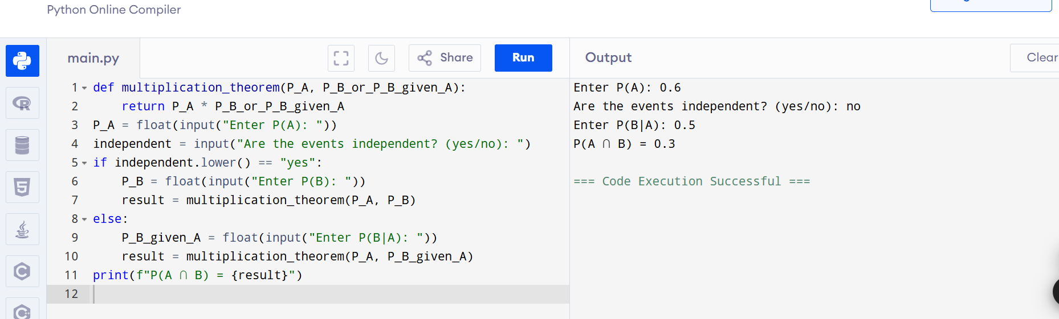

**Q)** A coin is tossed and a die is rolled:

• Probability of getting heads → P(A)=0.5P(A) = 0.5P(A)=0.5  
• Probability of getting a 4 on the die → P(B)=16≈0.1667P(B) = \frac{1}{6} \approx 0.1667P(B)=61​≈0.1667

What is the probability that both events occur — getting heads and getting a 4?

**Solution:** P(A∩B)=P(A)⋅P(B)

P(A∩B)=0.5⋅0.1667=0.0833

So, the probability of getting heads and a 4 is **0.0833.**

**3. Bayes’ Theorem**

**Explanation:**

Bayes’ theorem is used to find the probability of an event A given that another event B has occurred, especially when we know the reverse conditional probability, P(B∣A)P(B|A)P(B∣A).

It’s very useful in medical testing, spam filtering, machine learning, and other areas where we revise beliefs based on new evidence.

**Formula:**

P(A∣B)=P(A) ⋅ P(B∣A)/P(B)

**Program:-**

def bayes_theorem(P_A, P_B_given_A, P_B):

return (P_B_given_A * P_A) / P_B

P_A = float(input("Enter P(A): "))

P_B_given_A = float(input("Enter P(B|A): "))

P_B = float(input("Enter P(B): "))

result = bayes_theorem(P_A, P_B_given_A, P_B)

print(f"P(A|B) = {result}")

**Output:-** 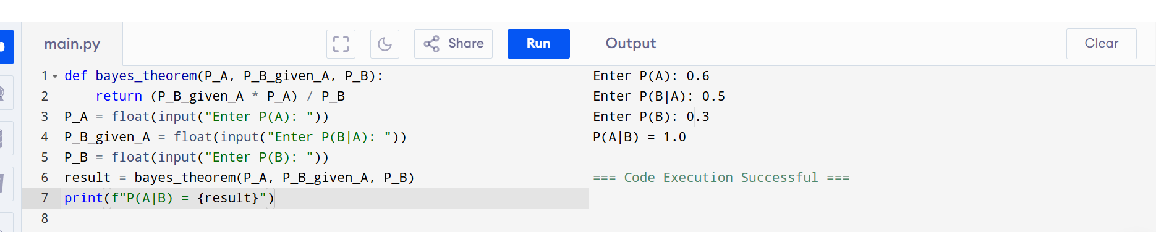

**Q)** A medical test is 95% accurate.

• 1% of people have the disease → P(A)=0.01P(A) = 0.01P(A)=0.01  
• If a person has the disease, the test is positive 95% of the time → P(B∣A)=0.95P(B|A) = 0.95P(B∣A)=0.95  
• The probability of testing positive in the entire population → P(B)=0.05P(B) = 0.05P(B)=0.05

What is the probability that a person actually has the disease, given that they tested positive?

**Solution:**

P(A∣B)=P(B)P(B∣A)⋅P(A)​

P(A∣B)=0.5 *0.95/0.01​=0.050.0095​=0.19

So, the probability that a person actually has the disease given a positive test is 0.19 (or 19%).